[http://127.0.0.1:8000/posts/5/](http://jump.bdimg.com/safecheck/index?url=x+Z5mMbGPAuCJCoZ31dwWz3uP4t2B4cGu0oeQVYs+BuT/zkN4PNea6r2zxYYPibx+qFXjyCc7qf2/tHI1yKEhhN5fumDlbv4r+i+KSVXnmBsiI4lOLf07r1xx2PfSFnKVfdkwJqFldMwPGbuJnYGNA==" \t "_blank) 是show.blade.php文章详情页 [http://127.0.0.1:8000/posts/create](http://jump.bdimg.com/safecheck/index?url=x+Z5mMbGPAuCJCoZ31dwWz3uP4t2B4cGu0oeQVYs+BsDrwirDZONUYGlFnjIbYaqqvbPFhg+JvH6oVePIJzup/b+0cjXIoSGE3l+6YOVu/iv6L4pJVeeYGyIjiU4t/TuvXHHY99IWcpV92TAmoWV0zA8Zu4mdgY0" \t "_blank)是create.blade.php文章创建页

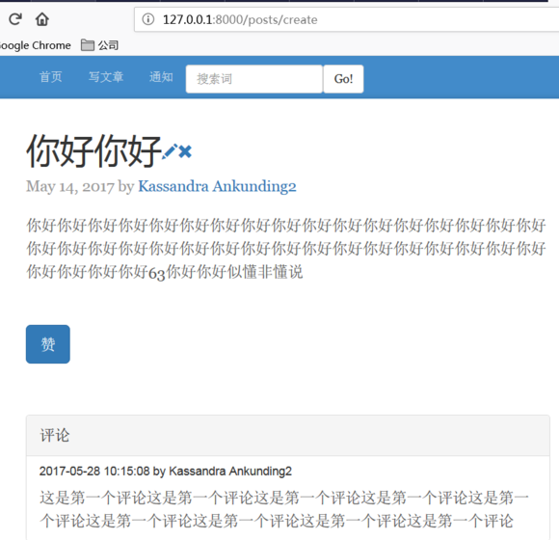

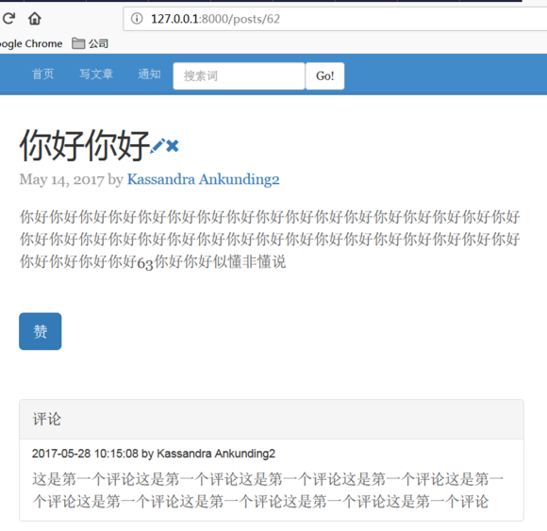

web.php  
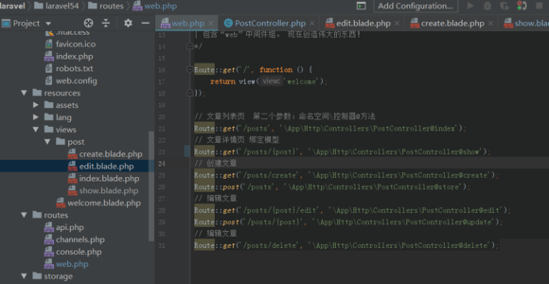PostController.php  
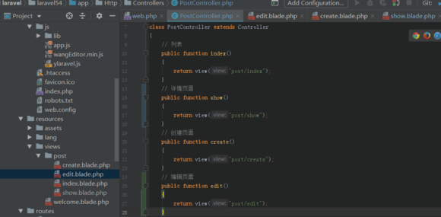

只改了web.php ，PostController.php show和create的路由也不一样,浏览器输入create的网址却指向show页面